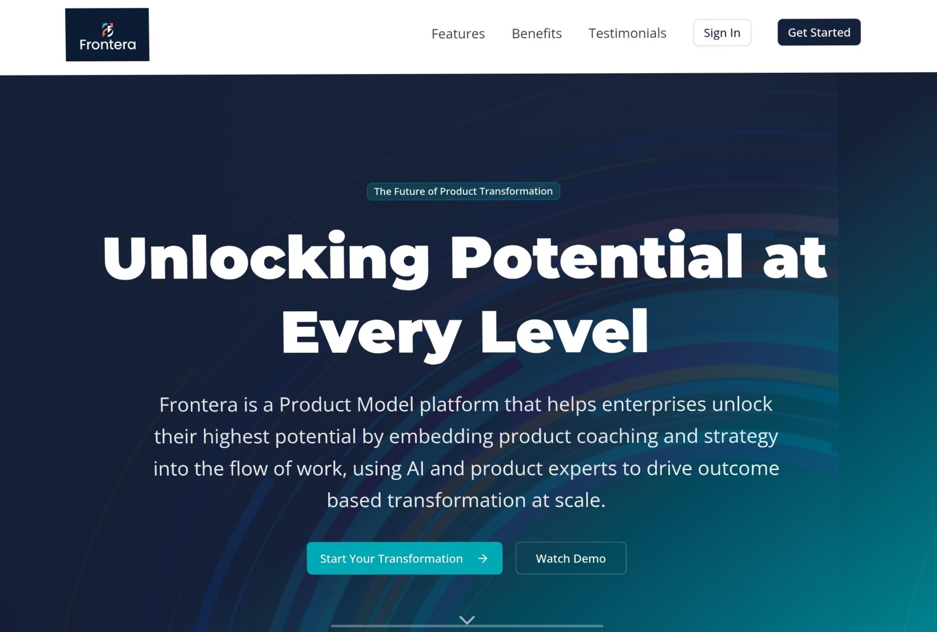
https://v0.app/chat/Frontera-landing-crS8fo6y9WQ?f=1&b=b_FVEiHFLqWNN
https://www.magicpatterns.com/c/izdnghhxzewhm2rx15fdoy

✅ Problem Statement

Product Model Transformations Are Failing Enterprises: the Frontera Platform Is Inventing the Future of Strategy and Product Model Coaching

The Problem:
Enterprise companies are under massive pressure to modernise — to move faster, work smarter, and deliver customer-centric, outcome-driven digital products. But transformation after transformation fails to stick. Why?
Because the playbooks are broken.
Big consultancies continue to dominate enterprise transformation — but they are stuck in the past. Their operating model "solutions" are still built in static PowerPoints, delivered through one-off workshops, and based on outdated mental models. These consultancies lack embedded coaching, don’t work in the flow of product delivery, and have no real mechanisms to sustain change.

They talk about being product-led, but they’ve never built products. They promise agility, yet deliver theatre. They introduce abstract frameworks that fail to reach teams on the ground. And they rarely — if ever — equip domain leaders (Product, Engineering, Design, Data) with the tools to lead real change.

The result? Strategy disconnected from execution, executive fatigue and lost market share. Teams are still shipping outputs instead of outcomes. And another round of transformation rebooted every two years — more expensive, and still ineffective.

The Opportunity:
It’s time for a new model — designed by real product leaders, not slide builders.
A model that embeds strategy into practice, that supports teams in real time, and that is driven by experts, powered by AI, , and measured by outcomes.

Introducing the Frontera Product Model Platform — the first enterprise-grade, modular coaching platform built to:
- Digitise and embed product strategy and methods at every level
- Bridge the gap between company vision and day-to-day team delivery
- Support ongoing capability development across roles and domains
- Deliver lasting transformation — not transformation theatre
This is not consultancy.
This is the product model platform of the future, which helps you rewire your organisation from within.

FOR IMMEDIATE RELEASE
Product Model Transformations Are Failing Enterprises: XLR8’s Frontera Is Inventing the Future of Strategy and Product Model Coaching
Date: August 2025
Contact: press@Frontera.delivery
Website: www.Frontera.transform

📰 Headline
XLR8 Launches “Frontera Coaching” — A First-of-Its-Kind AI-Powered Product Coaching Platform to Replace Outdated Consultancy-Led Transformation

🧠 Subheading
Legacy consultancies are stuck in the past. Frontera Coaching is the future of digital transformation: modular, AI-powered, practitioner-built, and designed to embed product strategy, team development, and outcome-based execution at enterprise scale.

📝 Body
[LONDON, UK] – Frontera, a modern product coaching and enablement company, today announced the launch of Frontera Coaching, the world’s first AI-powered, end-to-end product model transformation platform designed to help enterprises design, embed and continually enhance their product operating model and delivery capability— not through slide decks, but through intelligent, embedded learning systems.

For decades, legacy consultancies have charged millions to teach product principles—only to leave companies with slide decks, fleeting workshops, and disconnected models that rarely translate into team behaviour or improved customer outcomes. Executives and teams are left unfulfilled, unable to embed a true product operating model that drives growth and innovation.
In a world that moves at the pace of technology and AI innovation, this approach is broken.

Frontera Coaching changes everything.

Built by real product leaders, not theorists, Frontera Coaching combines the power of globally expert human and digital coaching, fuelled by generative and agentic AI with modular content, and domain-specific enablement to create lasting, enterprise-wide change.

“Big consultancies have had their day. The Frontera Platform is about real change—embedding product thinking, not just talking about it,” said [X], CEO of Frontera. “We’re giving companies the coaching, frameworks, tools, evidence, and support to build world-class product organisations—tailored to their strategy, customers and outcomes”

✨ What Frontera Coaching Delivers
Frontera is more than a learning tool — it’s a transformation system. It supports enterprise product evolution across four interconnected domains:
- Company & Product Strategy Agent
Built from product experts, with global expertise, this agent helps executive teams research, frame, and write product strategies that align to vision and value.
- North Star & OKR Agent
Drawing from and enhancing the best methods to define measurable customer and business outcomes that power strategic flywheels and real business impact.
- Team Mission, Vision & OKR House Agent
Inspired by leading Product led companies globally, this agent coaches product teams to define meaningful customer missions, align to strategy, and build outcome-first delivey.
- Competency Framework Agent
Using the latest in product development method and tooling this module enables domain leads to define, train, and evolve capability in Product, Engineering, Design, Data, and Delivery.
Every module is modular, intelligent, and interconnected — forming an end-to-end product operating model from strategy to execution, which you can configure for your enterprise.

🌟 Customer Example: Aberdeen
Aberdeen, one of the UK’s largest wealth and investment platforms, has adopted Frontera Coaching to replace its static product transformation program. In just months, it launched a new company-level product strategy, defined North Star metrics across verticals, and embedded OKR alignment down to the team level — all using XLR8’s coaching platform.
“Frontera helped us do what the big consultancies never could — translate strategy into action, and outcomes into culture. We now coach capability, not compliance.”
– Chief Product & Technology Officer, Aberdeen

🔍 FAQs
Q: Who is this for?
Frontera Coaching is designed for large enterprises ready to modernise how they build products — from digital-native scale-ups to legacy corporates struggling to adopt a product mindset. It supports leaders, teams, and domain specialists.
Q: How is this different from traditional consulting?
Unlike static decks or “one-and-done” workshops, Frontera is embedded, modular, intelligent, and coach-led. It supports real-time strategy execution, competency uplift, and product thinking that sticks — measured by outcomes, not activity.
Q: How is it delivered?
Via a modern digital platform with integrated AI agents, reusable frameworks, interactive training content, and human coaching — all tailored to learning style, maturity, and role.
Q: What does it cost?
Frontera is delivered as a modular subscription, starting from £80–£400 per user annually depending on the selected capability tiers (Foundation, Enablement, Accelerator).
Q. Does it replace your existing tool stack?
No, At Frontera we design our products and partnerships to enhance your product tool chain. We are strategic partners with Atlassian, Service Now, Linear, Dotwork…. Frontera helps you transform the effectiveness of your product development tool chain

🧭 The Future Is Product-Led
Frontera believes in a world where product strategy and execution are not fragmented, but connected. Where leaders are guided, not theorised. Where outcomes, not outputs, define success.
With Frontera Coaching, enterprises can finally leave behind legacy transformation and accelerate toward the product operating model of the future.
No more frameworks in silos. No more theatre. Just strategy, execution, and outcomes — connected.

📬 To learn more, book a demo, or explore partnership:
🔗 www.xlr8.delivery/Frontera
📧 Email: hello@xlr8.delivery

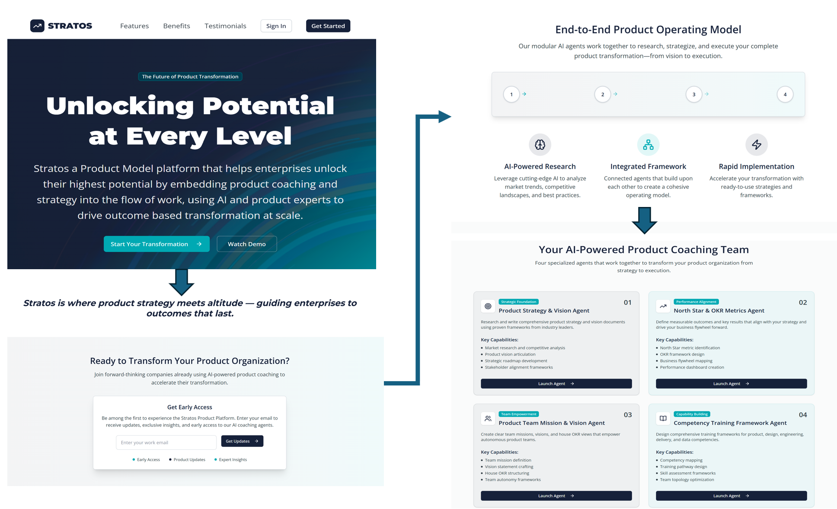

Frontera: Brand Concept
🌍 Vision
A world where enterprises unlock their highest potential by connecting strategy to execution — with clarity, intelligence, and speed.
Frontera exists to elevate how organisations build products. Frontera gives leaders and teams the vantage point to see where they are, where they’re going, and how to get there.

🎯 Mission
To embed product strategy and coaching into the flow of work, using AI and human expertise to:
- Replace static transformation theatre with living, adaptive systems.
- Empower leaders and teams with clarity of direction (the “North Star”).
- Enable measurable, outcome-driven product delivery at enterprise scale.
- Build enduring product cultures that sustain transformation long after consultancies leave.

🔑 Brand Identity
1. Brand Essence
- Elevation & Perspective: helping enterprises rise above noise and complexity.
- Intelligence & Precision: AI-powered coaching that adapts in real time.
- Momentum & Clarity: moving organisations forward with focus and energy.
2. Tone of Voice
- Confident but not arrogant
- Futuristic but practical
- Guiding, not preaching
- Clear, concise, outcome-oriented
3. Visual Identity (conceptual)
- Logo: Minimalist geometric shape (e.g. rising arc, orbit path, or layered horizon).
- Colour Palette:
  - Deep indigo/navy → trust, depth, professionalism
  - Electric teal/blue → digital intelligence, energy
  - White/silver accents → clarity, futuristic edge
- Typography: Modern sans-serif (e.g. Inter, GT America, or Circular) → clean and digital-first.
4. Brand Metaphors
- Altitude: seeing the bigger picture while staying connected to ground-level execution.
- Flight Path: guiding enterprises on a defined journey, with Frontera as navigator.
- Atmosphere: the protective layer enabling transformation to thrive.
5. Tagline Options
- “Clarity at Every Level.”
- “From Strategy to Outcomes.”
- “The Future of Product Transformation.”
- “Elevation for Product-Led Enterprises.”

🌟 Example Brand Narrative
Frontera isn’t consultancy. It’s not another framework in a slide deck.
It’s the platform that helps enterprises rise above the noise, connect strategy to delivery, and embed a true product culture. With AI-powered coaching and practitioner-built tools, Frontera gives leaders perspective, teams clarity, and organisations momentum.
Frontera is where product strategy meets altitude — guiding enterprises to outcomes that last.

Product Pricing – Frontera Coaching Platform

Prompt
I am looking at options for pricing a new Product Model coaching platform for large Enterprises. The platform is designed to transform and disrupt how Enterprises design, adopt and embed product models. There are significant challenges with how consultancies have promised and failed to support Enterprises in adopting product models and modern digital product development models which learn from more modern technology first companies.

We are building a platform which will blend human and digital coaching, including: core coaching modules in person, virtually or digital modules, AI based agents for each theme of the product: creating product strategy and vision, defining your companies north star.

Can you form the pricing suggestions by reviewing the writing of Madhavan Ramanujam and his podcast with Lenny?
For additional context. We are selling to Enterprises, who have seen multi million spend with the big consultancies fail to deliver results. They are trying to adopt product models to modernise their digital product capabilities and develop sustainable/ differentiated growth in their field. From a persona perspective we are talking to executive, or executive direct reports who are either accountable for the failed transformations to date, or are taking over and trying to turn it round with fear of another failure, inability to see transformation outcomes delivered, and working within legacy enterprises. What pricing structures would you propose to align product and customer outcomes.

I'll search for information about Madhavan Ramanujam's pricing philosophy and his podcast with Lenny to inform my recommendations for your Product Model coaching platform.
Madhavan Ramanujam Lenny podcast pricing strategy
10 results

The art and science of pricing… - Lenny's Podcast: Product | Growth | Career - Apple Podcasts
apple.com

The art and science of pricing | Madhavan Ramanujam (Monetizing Innovation, Simon-Kucher)
lennysnewsletter.com
The art and science of pricing | Madhavan Ramanujam (Monetizing Innovation, Simon-Kucher)
lennyspodcast.com

The art and science of pricing | Madhavan Ramanujam (Monetizing Innovation, Simon-Kucher)
spotify.com

Lenny Rachitsky on LinkedIn: The art and science of pricing | Madhavan Ramanujam (Monetizing… | 19 comments
linkedin.com
Pricing and scaling your AI product: Lessons from 400+ companies and 50 unicorns | Madhavan Ramanujam
lennysnewsletter.com
Summary: The art and science of pricing with Madhavan Ramanujam
lennyspodcast.com
Madhavan Ramanujam has worked with Uber, Etsy, Amazon & 200+ others on pricing strategy
lennyspodcast.com
Lenny's Podcast: Product | Career | Growth | Lenny Rachitsky | Substack
lennysnewsletter.com
Pricing your AI product: Lessons from 400+ companies and 50 unicorns | Madhavan Ramanujam
spotify.com
Let me get more specific details about Madhavan's pricing philosophy and frameworks:

Fetched The art and science of pricing | Madhavan Ramanujam (Monetizing Innovation, Simon-Kucher)
lennysnewsletter.com
Based on Madhavan Ramanujam's pricing philosophy from his work with enterprise companies and his frameworks, here are my pricing structure recommendations for your Product Model coaching platform:
Core Pricing Philosophy Alignment
Ramanujam emphasizes that "willingness to pay" conversations should happen "early and often" and that successful pricing is built around customer value perception rather than cost-plus models. Given your target audience's pain points - failed multi-million dollar consultancy investments and fear of repeated failure - your pricing must directly address these concerns.
Recommended Pricing Structures
1. Outcome-Based Pricing with Risk Mitigation
Structure: Success-fee hybrid model
- Base Fee: 30-40% of total value (covers core delivery costs)
- Success Fee: 60-70% tied to measurable transformation outcomes
- Risk Cap: Maximum exposure limited to 12-18 months of executive salaries affected
Rationale: This directly addresses executives' fear of another failed transformation by aligning your success with theirs. The base fee ensures your operational viability while the success component demonstrates confidence in your methodology.
2. Modular Value-Based Pricing
Structure: Tiered engagement levels
- Foundation Tier ($150K-250K): Core coaching modules + digital platform access
- Transformation Tier ($400K-600K): Full coaching + AI agents + custom implementation
- Enterprise Tier ($800K-1.2M): Everything + ongoing support + multi-division rollout
Key Innovation: Each tier includes "failure insurance" - if defined milestones aren't met within 6 months, additional services are provided at no cost.
3. Subscription + Performance Model
Structure: Ongoing engagement with performance multipliers
- Monthly Platform Fee: $25K-50K (covers digital coaching, AI agents, basic support)
- Quarterly Performance Bonus: 0.5-2x monthly fee based on KPI achievement
- Annual Outcome Bonus: Up to 3x total annual fees for breakthrough results
This model works well because Ramanujam advocates for understanding "how many customers you should be talking to" and "when to revisit pricing" - the subscription model allows for continuous value demonstration and pricing optimization.
Key Pricing Tactics Based on Ramanujam's Framework
Segmentation Strategy
- Turnaround Executives: Higher base fees, lower success multipliers (they're more risk-averse)
- Growth-focused Leaders: Lower base fees, higher success multipliers (more willing to bet on outcomes)
- Legacy Enterprise vs. Digital-forward: Different packaging emphasizing cultural change vs. process optimization
Behavioral Pricing Elements
- Anchoring: Lead with your highest-value "Enterprise Transformation" package
- Loss Aversion: Frame pricing around "cost of continued failure" vs. "cost of transformation"
- Social Proof: Include case studies showing ROI multiples in pricing presentations
Bundling Strategy (Leaders, Killers, Fillers)
- Leaders: Core coaching methodology and AI strategy agents
- Killers: Premium support, custom integrations, executive access
- Fillers: Digital modules, peer network access, industry benchmarking
Implementation Recommendations
Initial Pricing Conversations
Start every engagement with willingness-to-pay discovery:
- "What was the total investment in your previous transformation attempt?"
- "What's the annual cost of not having effective product capabilities?"
- "What specific outcomes would make this investment feel obvious?"
Contract Structure
- Phase 1 (3 months): Diagnostic and foundation - fixed fee
- Phase 2 (6-9 months): Implementation - outcome-based pricing kicks in
- Phase 3 (ongoing): Sustainment - subscription model
Success Metrics Alignment
Tie pricing to metrics that matter to executives:
- Time-to-market improvements
- Product revenue growth
- Digital capability maturity scores
- Employee engagement in product roles
- Customer satisfaction improvements
This approach transforms your pricing from a cost conversation into a risk mitigation and value creation discussion, directly addressing the psychological and business concerns of executives who've experienced transformation failures. The modular structure allows you to compete against both boutique consultancies and large firms while differentiating through your unique risk-sharing approach.

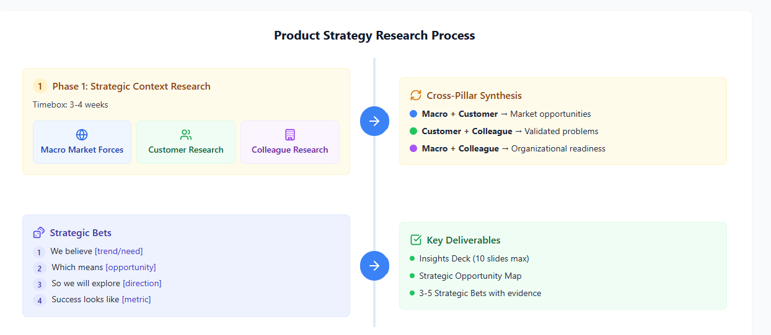
https://www.magicpatterns.com/c/izdnghhxzewhm2rx15fdoy

📘 Product Strategy Research Playbook
🎯 Purpose
Guide product teams through systematic research to inform strategic positioning and product bets before Strategic Flow and discovery phases.
Teams: Stimulate teams to perform macro, divergent thinking from both market and customer forces and trends.

🔎 Phase 1: Strategic Context Research
Timebox: 1–2 weeks
Three Research Pillars
🌍 Macro Market Forces
- Competitive Landscape → direct/indirect competitors, substitutes
- Economic Dynamics → market size, growth, business model evolution
- Partner & Ecosystem → value chain, dependencies, make vs. buy
- Regulatory Forces → current/emerging regulation, privacy, compliance
- Technology Dynamics → platform dependencies, emerging tech, integration ecosystem
- Comparators → how other industries/markets solved similar challenges
- Signals Radar → strong vs. weak signals to monitor
In market analysis, a "signals radar" refers to a system or process that actively detects and tracks market signals, providing real-time awareness of news, prices, and trends. It acts as a tool to visualize and understand market changes, helping teams align on strategic goals and prioritize actions.

- Future Scenarios → Ideate on 2–3 potential futures (optimistic, pessimistic, disruptive), not solutions……

👥 Customer Research
- Data Sources → analytics, databases, user interviews, support tickets
- Segmentation & Prioritisation → which customer groups are most attractive
- Journey Mapping & JTBD → tasks, goals, context (where known, not deep JTBD now)
- Adoption & Barriers → what drives/blocks switching
- Unmet Needs Radar → plot importance vs. satisfaction to find whitespace
- Outcome Framing → customer outcomes in measurable terms (time saved, risks avoided)

🏢 Colleague Research
- Leadership → strategy priorities, market positioning, resource constraints
- Sales/Success → deal objections, win/loss factors, expansion opportunities
- Support → recurring issues, feature requests, customer workarounds
- Marketing → message resonance, discovery channels, brand perception
- Engineering → constraints, advantages, innovation pipeline
- Field Shadowing → observe sales calls, support chats, adviser meetings
- Alignment Check → note gaps between strategy and frontline stories
- Risk Radar → risks colleagues see if product moves in certain directions

🔄 Cross-Pillar Synthesis
Forced Triangulation:
- Macro + Customer → market opportunities
- Customer + Colleague → validated problems
- Macro + Colleague → organisational readiness
Outputs:
- Key Insights Deck (max 10 slides)
- Strategic Opportunity Map (where needs intersect with market/tech)
- List of Initial Strategic Bets (backed with evidence)

🎲 Strategic Bets: Expression Format
- We believe [trend/customer need]
- Which means [opportunity/problem space]
- So we will explore [hypothesis/initiative direction]
- Success looks like [leading indicator metric]

🛠 Guardrails & Tools
- Timebox: 1–2 weeks max research
- Evidence Grading: High / Medium / Low confidence
- Templates Provided: Ecosystem map, competitor teardown, JTBD canvas, unmet needs radar, synthesis board

✨ Lenses of Advantage
Frame opportunities through potential durable advantage:
- Customer Insight (unique understanding of need)
- Distribution (reach, channels, trust)
- Technology/Platform (data, integration, IP)
- Business Model (recurring revenue, lower CAC)

✅ Deliverables Checklist
- Insights Deck (10 slides)
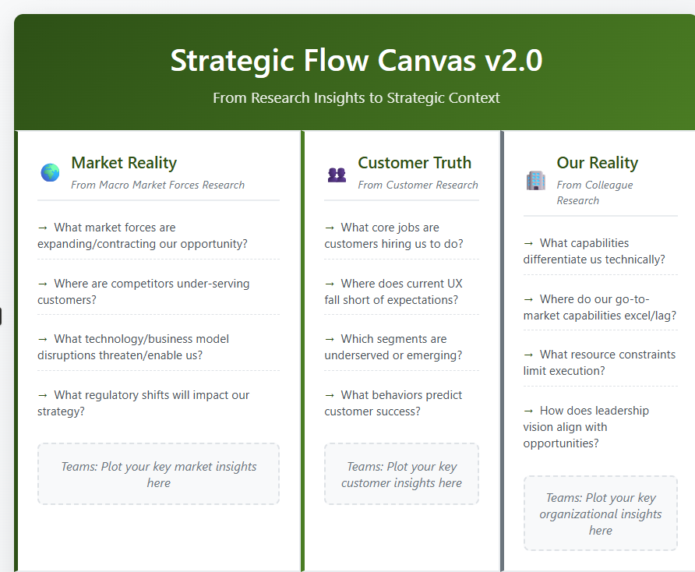
- Strategic Opportunity Map
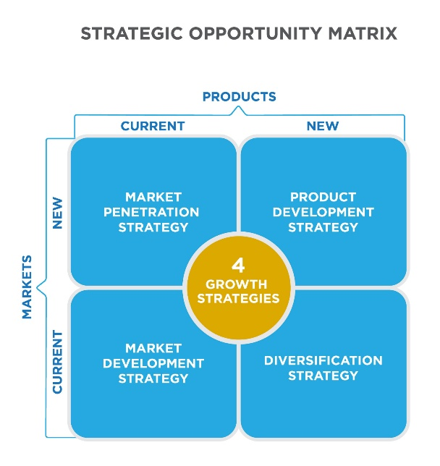
- 3 -5 Play to Win Hypotheses
This ensures research reliably turns into a focused, evidence-backed strategy foundation.

Strategic Flow Canvas v2.0
From Research Insights to Strategic Context
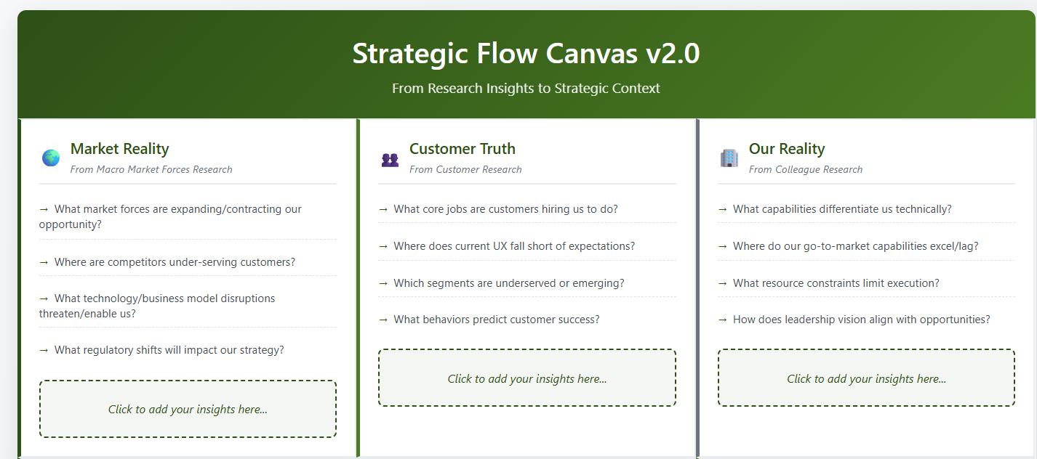
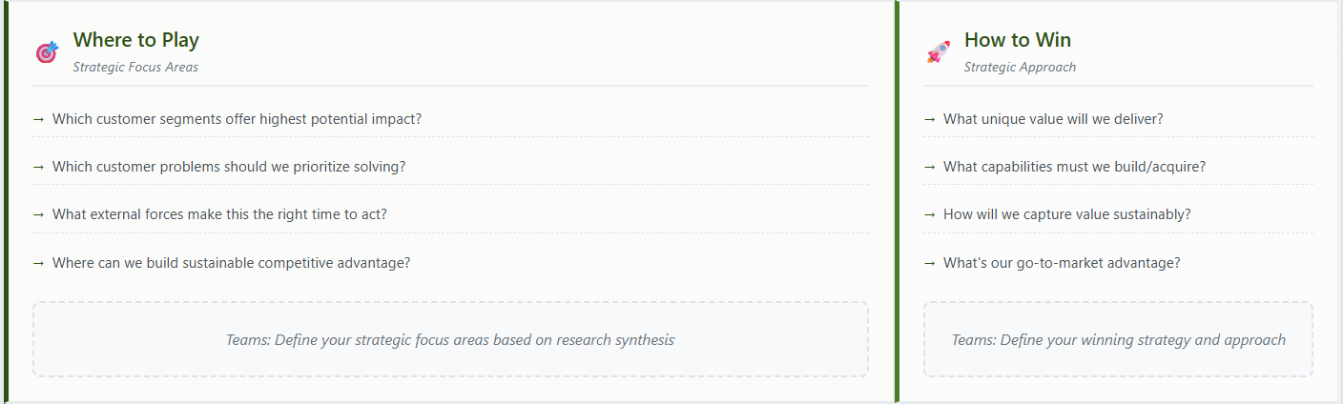
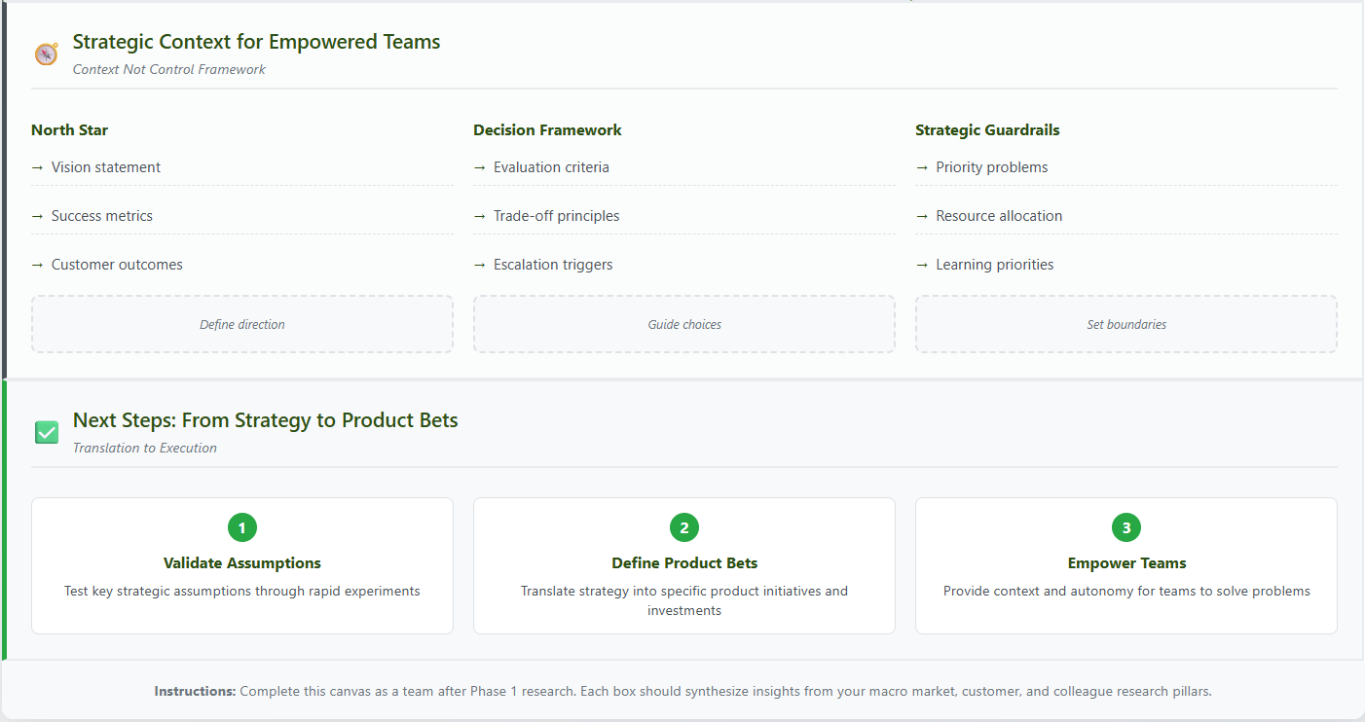

Framework Overview
This canvas translates Phase 1 research findings into strategic context that empowers product teams to make informed decisions about where to play and how to win.

SECTION 1: MARKET REALITY
Synthesized from Macro Market Forces Research
Market Position & Opportunity
- Current Landscape: How do we stand relative to competitors today?
- Market Momentum: What forces are expanding/contracting our opportunity?
- Disruption Vectors: What emerging technologies or business models threaten/enable us? Which Fintech, Wealthtech, Consumer tech journeys can we take inspiration from
- Regulatory Runway: What compliance/regulatory shifts will impact our strategy?
Competitive Dynamics
- Competitive Gaps: Where are competitors under-serving customers?
- Technology Moats: What technical advantages can we build/defend?
- Business Model Innovation: How can we compete differently on monetization?
- Platform Dependencies: What ecosystem relationships are strategic vs. risky?

SECTION 2: CUSTOMER INSIGHTS
Synthesized from Customer Research
Customer Problem-Value Fit
- Core Jobs-to-be-Done: What outcomes are customers truly hiring us for?
- Experience Gaps: Where does current UX fall short of customer expectations?
- Segment Opportunities: Which customer segments are underserved or emerging?
- Journey Friction: What prevents customers from achieving their desired outcomes?
Adoption & Growth Patterns
- Success Indicators: What behaviors predict customer success and expansion?
- Onboarding Barriers: What prevents new customers from realizing value quickly?
- Retention Drivers: What keeps customers engaged long-term?
- Viral/Network Effects: How can satisfied customers drive growth?

SECTION 3: ORGANIZATIONAL CONTEXT
Synthesized from Colleague Research
Capability Assessment
- Technical Strengths: What engineering/platform capabilities differentiate us?
- Resource Constraints: What limits our ability to execute effectively?
- Innovation Pipeline: What R&D investments are positioned to unlock new value?
- Operational Excellence: Where do our go-to-market and support capabilities excel/lag?
Strategic Alignment
- Leadership Vision: How does product strategy align with company direction?
- Cross-functional Insights: What do sales, support, and marketing data tell us?
- Cultural Readiness: How prepared is the organization for strategic shifts?
- Investment Priorities: Where is leadership willing to double-down vs. divest?

SECTION 4: STRATEGIC SYNTHESIS
Where to Play Hypotheses
Market segments, customer problems, and competitive positions to focus on
- Target Segments: Which customer segments offer the highest potential impact?
- Problem Focus: Which customer problems should we prioritize solving?
- Market Timing: What external forces make this the right time to act?
- Competitive Advantage: Where can we build sustainable differentiation?
How to Win Approach
Capabilities, business models, and value propositions that will drive success
- Value Proposition: What unique value will we deliver to win?
- Capability Bets: What capabilities must we build/acquire to win?
- Business Model: How will we capture value sustainably?
- Go-to-Market: How will we reach and convert target customers?
Strategic Constraints & Enablers
- Must-Haves: What capabilities/partnerships are table stakes?
- Deal-Breakers: What factors could make our strategy unviable?
- Success Metrics: How will we measure progress toward strategic goals?
- Resource Requirements: What investments are needed to execute?

SECTION 5: STRATEGIC CONTEXT FOR TEAMS
The "context not control" framework for empowered teams
North Star Definition
- Vision Statement: Where are we heading long-term?
- Success Metrics: What outcomes indicate we're winning?
- Customer Outcomes: What customer value are we optimizing for?
- Business Outcomes: What business results does this strategy deliver?
Team Empowerment Context
- Strategic Guardrails: What principles should guide all product decisions?
- Priority Problems: What customer/business problems need solving most?
- Success Criteria: How will teams know they're moving in the right direction?
- Resource Allocation: How should teams think about effort and investment trade-offs?
Decision-Making Framework
- Evaluation Criteria: How should teams assess opportunities and solutions?
- Trade-off Principles: When faced with competing priorities, how should teams decide?
- Escalation Triggers: What decisions require leadership input vs. team autonomy?
- Learning Priorities: What assumptions most need testing/validation?

CANVAS COMPLETION GUIDE
Step 1: Research Synthesis (Week 1)
- Review all Phase 1 research findings
- Identify top 3-5 insights from each pillar
- Look for cross-pillar themes and tensions
- Document key assumptions and uncertainties
Step 2: Strategic Translation (Week 2)
- Map insights to canvas sections
- Develop Where to Play/How to Win hypotheses
- Define strategic constraints and enablers
- Align with leadership on strategic direction
Step 3: Team Context Creation (Week 3)
- Translate strategy into actionable team context
- Define success metrics and decision criteria
- Create empowerment framework
- Validate with key stakeholders
Step 4: Validation & Iteration (Ongoing)
- Test strategic assumptions through product bets
- Gather feedback from empowered teams
- Iterate based on market/customer response
- Maintain strategic context as market evolves

SUCCESS INDICATORS
- [ ] Clear connection between research insights and strategic choices
- [ ] Empowered teams have sufficient context to make decisions
- [ ] Strategic direction differentiates from competitive approaches
- [ ] Resource allocation aligns with strategic priorities
- [ ] Success metrics measure both customer and business outcomes

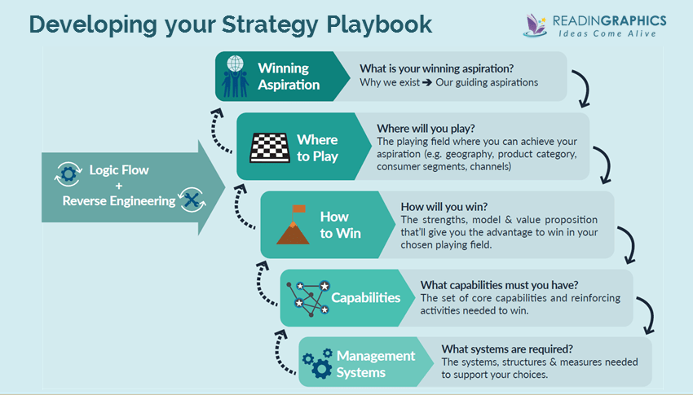

Getting Started: Your Strategy Playbook
The 5 sets of strategic choices above affect what you do and don’t do. Obviously, it’s not easy or straightforward to find good answers. There are many strategy tools (e.g. SWOT analysis or BCG Growth Matrix) that you can use to brainstorm and filter ideas, but where do you start?
Basically, you should start with a rough definition of your winning aspiration, then move on to spend more effort on your where-to-play and how-to-win choices, because they form the heart of your strategy and define where/how you will play to win. To find and choose the best where-to-play and how-to-win choices, the authors recommend using (a) the strategy logic flow and (b) reverse engineering. These, combined with the 5 strategic choices of the choice cascade, form your strategy playbook.

In a nutshell:
- The strategy logic flow gives you a structured approach to think through your strategy, using 7 questions along 4 key dimensions to analyze your organization’s current realities, and help you to generate strategic ideas/choices.
- The reverse engineering process helps you to choose the options that give you the highest chances of success.
